

Company Background

Business Structure/organization

Owner #2

Owner #2 Bio

Owner #1 Bio

**OUR TEAM & ORGANIZATION**

Contact information

Insert Mission Statement

Place Logo Here



**GUEST PROBLEM & OUR SOLUTION**

Guest Problem

Our Solution

Owner #1

**OUR PRODUCTS**

Product #1

Product #2



Product #3





Product #5



Product #6



Product #4



Product descriptions, sources, seasonality, etc.

List 3 to 4 marketing tactics each with 2 to 3 sentences

**MARKETING & SOCIAL MEDIA**

Explain how social media will be used, number of posts, etc. How will new follower be gained, how comments and reviews will be handled.

Explain how your marketing & social media will reach your target guests. Your social media accounts should be the same as your target guests.



**COMPETITION**

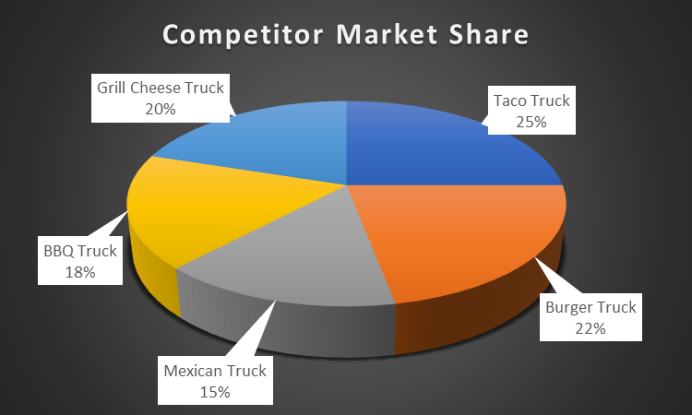

Summarize your Quick Shop visits. Summarize SWOT

How You Are Better Than the Competition.

**FINANCIAL PROJECTIONS**





